Grade 4
Chance Hz

Description: | Students will:  Modify the size and color of an ellipse from Supplies  Make a script with the forward and turn tiles.  Change the heading with the conditional statement: if obtrudes.  Use increase by a random number in the heading tile.  Use the Sound tiles to assign a frequency to the ellipse.  Make copies of the ellipse modify their color, size, and script.  Use a playfield to limit the motion.  Experiment with different lengths and widths for the playfield.  Experiment with forward by values to control the polyphony.  Experiment with starting location of shapes to control the polyphony.  Experiment to control the location so the shapes never touch simultaneously, or so they do touch simultaneously every cycle.  Add a title.  Add a flap if additional information is needed.
Project View | 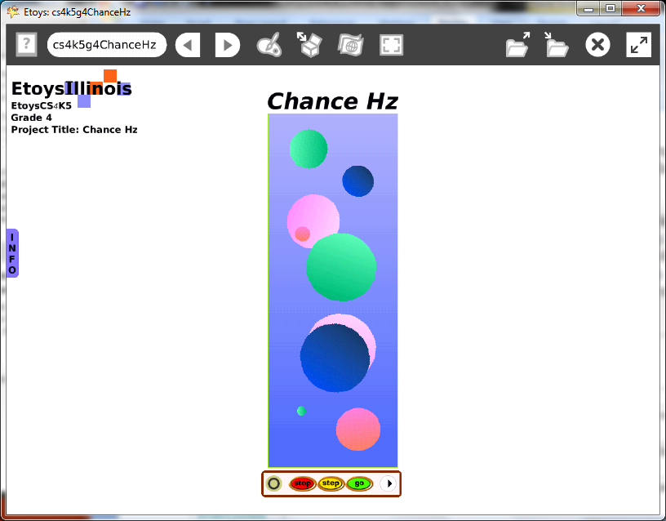
Subject: | Mathematics, Music
Etoys Quick Guides | Click the question mark in Etoys to open the set of interactive tutorials for basic tools and techniques.
Vocabulary: | Obtrudes, patterns, rhythm, polyphony, hertz, Hz, multiply, divide, x and y locations, forward by, heading. ratios, scale factors
Lesson 1:  Halo: Color Properties Sheet  Script Tiles: Forward and Turn  Script Tiles: Tests  Script Tiles: Sound Category  Script Tiles: Heading  Navigator Bar: Keep Find Project | Get an ellipse from Supplies. Modify the color using its fill and border tiles.  Make a script with forward by and bounce tiles in it.  Add a conditional statement.  Use the frequencies chart below to choose pitches.  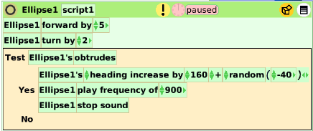  Make copies of the ellipse and change their properties and scripts.  Give students time to experiment.  There will be noise.  Keep the project. Call it nameHz. E.g. KateHz
Lesson 2:  Halo: Size, Color, Copy  Script Tiles: Scale Factor | Get a playfield from Supplies. Use playfield’s Viewer category fill and border to change the color.  Put the ellipses in it. Students should make as many copies and modify them as they want for their music.  Experiment with the size of the playfield to control the polyphony.  Experiment forward speeds to control the rhythm. Listen.  Multiply the speed of one ellipse to make the speed of another. Multiply its speed to make the speed of a third ellipse. Experiment with ratios. Listen.  Experiment to control size and speed so that one circle’s pitch is repeating twice as often as another’s pitch. Or make one pitch the double of another. Listen.  Use the scale factor to make exact size ratios between the ellipses sizes.  Give students time to experiment.  Give students time to try other student’s projects.  Give students time to revise their project.  Keep the project.
Standards: | Common Core Standards  Mathematics: 4.OA.5; 4.NBT.5; 4.NF.2;4.MD.5.a.b,6.7;4.G.1.3  Bloom’s Taxonomy/Cognitive Domain:  Knowledge: describes, selects  Comprehension: estimates  Application: constructs, discovers  Analysis: analyzes, experiments  Synthesis: categorizes, explains  Evaluation: compares, reviews  NETS:  1. a, b, c  4. a, b, c, d
Resources: | Etoys Help Quick Guides: always available in Etoys. Open Etoys and click the question mark to open a set of interactive tutorials of basic tools and techniques.  www.etoysillinois.org projects, lesson plans, software download  www.mste.Illinois.org more math, science, and technology resources  www.corestandards.org Common Core Standards  www.squeakland.org software and Etoys projects  www.nctm.org Standards and Focal Points for each grade level
kh February 2011
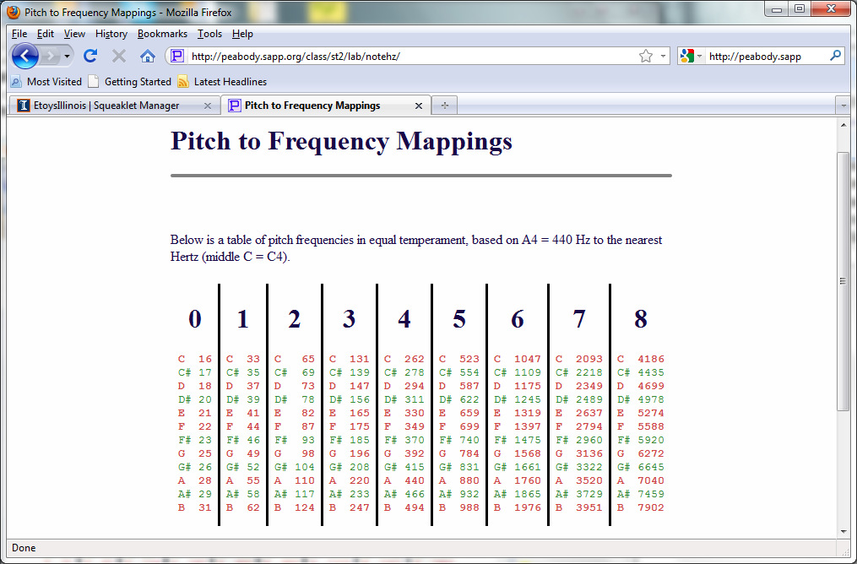
http://peabody.sapp.org/class/st2/lab/notehz/

